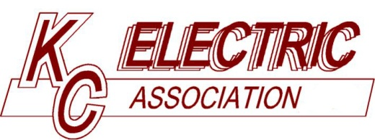 |  | Board of Directors Policy
Subject: Member Complaints and Related Matters |  |  |  | Policy No: 505
Original Issue: 6-22-93 | Last Revised: 7-23-13 |  | Last Reviewed: 5-27-25 | Page: 1 of 1
OBJECTIVE:
To specify how member complaints are to be handled by Board of Directors and management of K.C. Electric.
POLICY:
If and when a member of K.C. Electric chooses to bring a complaint regarding K.C. Electric policies, procedures, rate tariffs, or other matters to K.C. Electric’s attention, the following process shall be communicated to the complaining member:
- A member should first attempt to resolve the issue with the staff or management of K.C. Electric.
- If the matter is still not resolved, then the member may choose to:
  - Contact a member of the Board of Directors. Each Director shall make available to the membership a contact method by providing an email address, phone number, or mailing address on the K.C. Electric website. A member who wishes to contact a Director should use the method of contact provided.
  - Make a public comment during a regular meeting of the Board of Directors. At each regular meeting of the Board of Directors, the membership is allowed a time for Public Comment as specified in the Bylaws of K.C. Electric, Article V, Section 2 (a).
  - File a formal written complaint with request for Board of Directors action at a regular meeting of the Board of Directors. A formal written complaint with request for Board of Directors action shall be submitted at least ten days prior to the regular scheduled meeting. The Board President shall include the complaint as an Agenda item of the meeting and the written complaint shall be distributed to the Board of Directors in the monthly Board of Directors packet.
After hearing the complaint, the Board of Directors may rule on the matter. The decision of the Board of Directors shall be final.
ACCOUNTABILITY:
Board of Directors
General Manager

Attested: _________________________________________________  Secretary | Date: __________________

